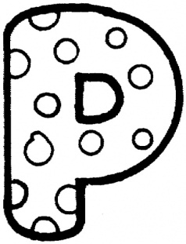
Psychology Department
Summer task
Complete all the tasks below and hand them in on your first Psychology lesson of September. Alternatively, if you cannot print this booklet then please complete it digitally and email to Mrs S K Sagoo (SSagoo@handsworth.bham.sch.uk) before or during your first Psychology lesson.
- Read the theory below and summarise it in 8 bullet points

Social learning theory (SLT) suggests that aggressive behaviours are learnt by observing others. Individuals, particularly children, observe their role models to learn what situations people are likely to be rewarded for their aggressive behaviour and when they are likely to be punished for aggressive behaviour. This process is known as vicarious learning. As a result, children imitate aggressive acts when they feel that their act of aggression will produce a reward/ be reinforced.
For social learning to take place, four conditions must be met. The child must first focus and pay attention to the behaviour of their role model. The child must then retain the information by storing the behaviour in to their long term memory. The child must then be able to reproduce the behaviour they have observed. Consequently, they must possess the capabilities and skills needed to imitate the aggressive behaviour. Finally the child must form a mental representation of the behaviour and believe that the expectation of reward is greater than the expectation of punishment.
If a child is rewarded for their aggressive behaviour (e.g. by acquiring status or being praised by others) they become more likely to repeat that action in similar situations in the future. For example, a child who successfully bullies other children learns that aggression towards others is likely to produce rewards. Children who are less successful in their use of aggression tend to be less aggressive individuals”

- Read through the extract below. Highlight the Aim, Procedure, Findings, Conclusion of this study

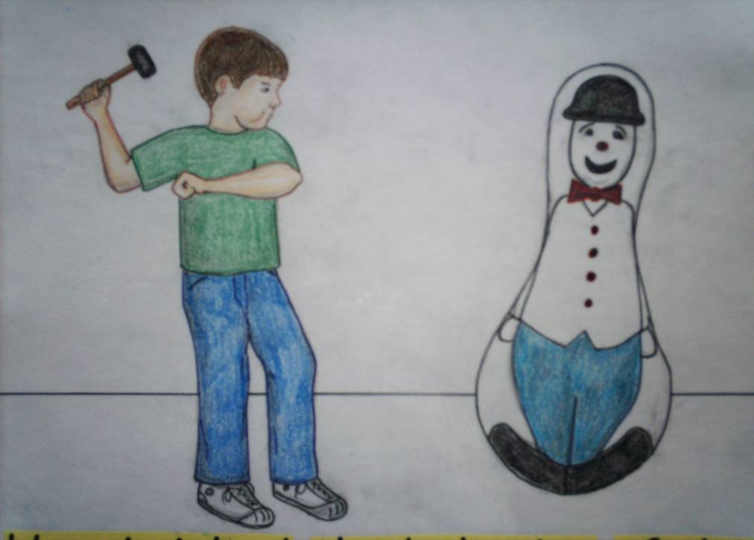
Bandura and Walters (1963)
Bandura and Walters wanted to investigate whether aggressive behaviour can be learned through observation
The participants were male and female children ranging from 3-5years. The children were recruited from the Stanford University nursery. The sample was divided into three groups. Each group saw a different ending to a film of an adult model behaving aggressively towards a bobo doll.
Group 1: saw the model rewarded for showing aggressive behaviour
Group 2: saw the model punished for showing aggressive behaviour
Group 3: observed the model but there were no consequences for aggressive behaviour
Following exposure to the model, children were frustrated by being shown attractive toys which they were not allowed to play with. They were taken to a room where, among other toys, there was a bobo doll. The children were filmed and observed via a two way mirror.
Bandura and Walters found that:
- Children in group one showed a high level of aggression in their own play
- Children in group two showed a low level of aggression in their play
- Children in the no-reward, no-punishment control group were somewhere in between these two levels of aggression.
This suggests children learn vicariously; they learn about the likely consequences of actions by watching other adult role models

- Use the extract to complete the sheet below

Approaches in Psychology
Key Study- Research into ……………………………………………….
Key Psychologist:
Topic:
Research Method:
Aims
Procedures (method, sample, experimental design, data collection, procedure)
Findings
Conclusions
Evaluation

- Select two of the following disorders and complete the tables below:
- Depression
- OCD
- Phobias
- Schizophrenia

Name of the disorder
Symptoms
How common is this disorder?
Potential causes
Treatments
Well known individual who has had/currently suffers from the disorder

Name of the disorder
Symptoms
How common is this disorder?
Potential causes
Treatments
Well known individual who has had/currently suffers from the disorder

